30th October 2017

**Chilton & Michelisz Reign in WTCC Japan**

The FIA World Touring Car Championship 2017 witnessed Rounds 15 and 16 at Twin Ring Motegi in Japan this weekend. The Championship which has the Japanese premium tyre manufacturer YOKOHAMA as Official tyre supplier had to deal with harsh weather before and during the event.

Earlier in the week, a Typhoon had delayed the preparations of the teams and on race day, strong rains added to the difficulties at Motegi. The poor weather however contributed to an action-packed Opening Race, which marked Kevin Gleason’s first reverse-grid pole. Although the American led away from the front, he was not able to maintain his lead and slid wide at the first turn allowing Tom Chilton into a lead he would not lose. Chilton’s victory for the Sebastien Loeb’s team also means he still maintains an outside chance for overall Championship glory, and leads the WTCC Trophy challenge for non-works teams. “The Opening Race was fantastic, stated Chilton, adding they tweaked the car after qualifying and the result was perfect”. Yann Ehrlacher and Esteban Guerrieri – Tiago Monteiro’s stand-in at Honda – completed the Opening Race podium.

Meanwhile in the Main Race, Norbert Michelisz bagged a vital home win for Honda and also remains firmly in contention for the FIA World Touring Car Championship crown. With four races left and a maximum of 120 points up for grabs, the Castrol Honda World Touring Car Team driver trails Polestar Cyan Racing’s Thed Björk by 16.5 points with Nicky Catsburg, Björk’s Volvo team-mate just 2.5 points behind Michelisz in third. Catsburg and Néstor Girolami joined Michelisz in the Main Race top three.

While the Opening Race ran to its scheduled 11 laps, worsening weather and track conditions meant part of the Main Race ran behind the Volvo V60 Polestar safety car with the race stopped after the leader had completed 10 laps, the amount required for full points to be awarded.

The FIA World Touring Car Championship continues on 16th-17th November at the WTCC Race of Macau.

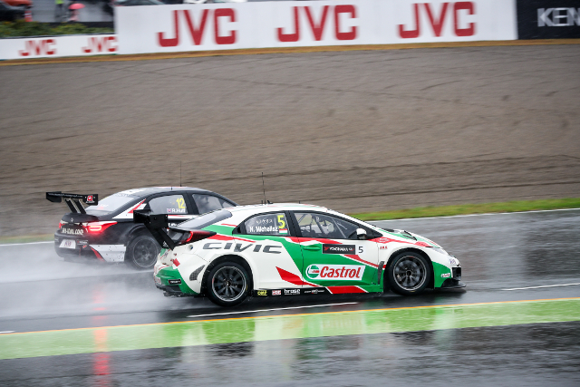

*Action-in-Japan-with-WTCC*

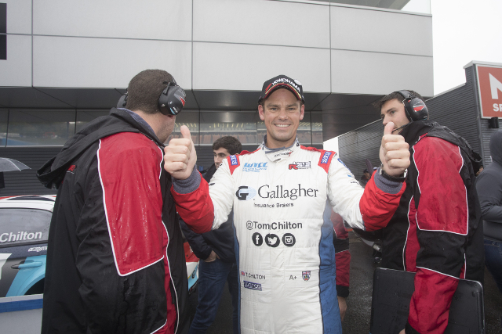

*Smiling-Chilton-celebrates-victory-in-opening-race*